|  |
| --- |
| *CometPark* |
| **System Requirements Analysis** |
| **SE 6387 Advanced Software Engineering Project**  **R.Z. Wenkstern**    ***02/27/2014*** |

|  |
| --- |
| **Group *B*** |
| **Arunkumar Manickam** |
| **Hariprasad Natarajan** |
| **Prasanna Venkatesh Venkitasamy** |
| **Rekha Muthulakshmi Nachadalingam** |

# Revision History

|  |  |  |  |
| --- | --- | --- | --- |
| **Version** | **Date** | **Decription** | **Authors** |
| 1.0 | 02/27/2014 | Completed initial draft | Prasanna,Hari,Rekha,Arun |

Contents

Revision History 2

1. Domain Model 1

2. System Use Case Diagrams 2

2.1 Level 0 UCD 2

2.2 Level 1 UCD 3

2.3 Level 2 UCD 4

3. Use Case Specification in Brief Format 5

4. Traceability Matrix 11

Appendix A: Glossary 12

# 1. Domain Model

The following diagram shows the Domain model of the CometPark system.

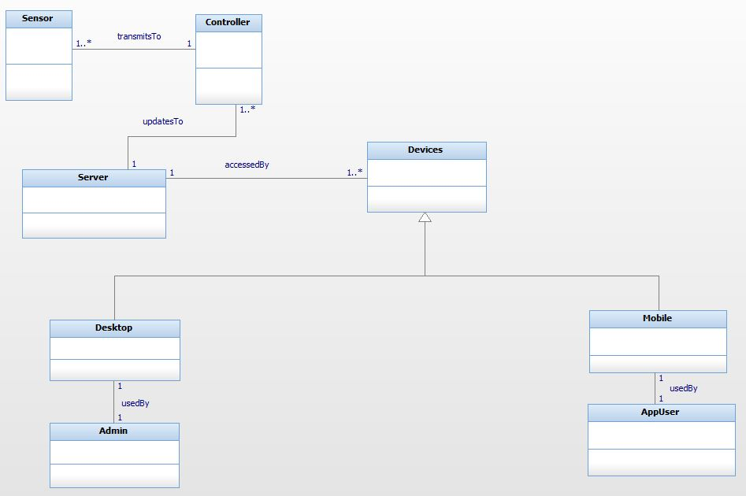

Figure 1 Domain Model of the CometPark System

# 2. System Use Case Diagrams

## 2.1 Level 0 UCD

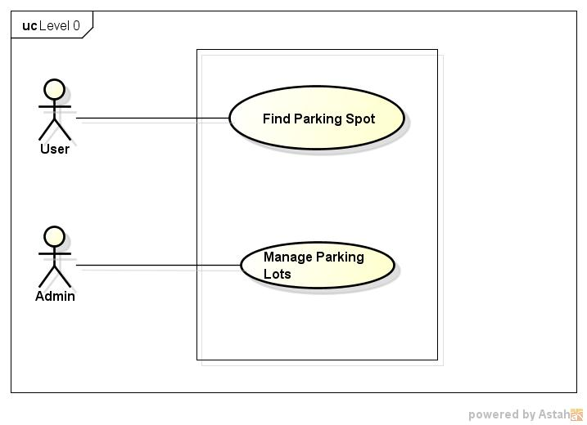

Figure 2: Level 0 Use Case Diagram

## 2.2 Level 1 UCD

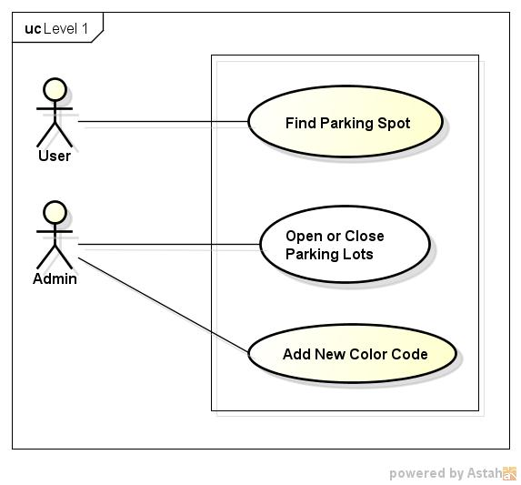

Figure 3: Level 1 Use Case Diagram

## 2.3 Level 2 UCD

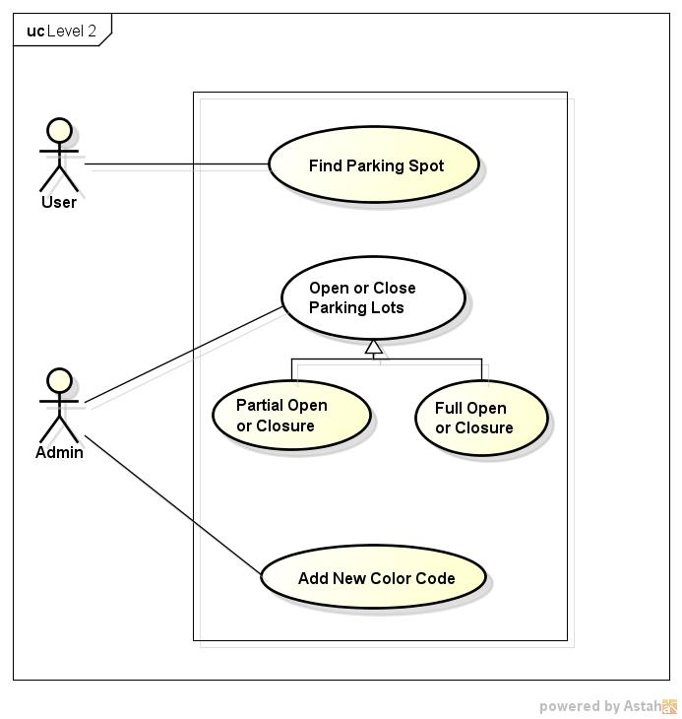

Figure 4: Level 2 Use Case Diagram

# 3. Use Case Specification in Brief Format

**3.1 Level 0 Use Cases**

|  |  |
| --- | --- |
| Use Case 0.1 | |
| ID: UC 0.1 (Level 0) | **Type:** *Base* |
| Name: | Find Vacant Parking Spot |
| Owner: | Arunkumar, Hariprasad, Prasanna Venkatesh, Rekha Muthulakshmi |
| Purpose: | To find a vacant parking spot near the user. The user will specify the number of spots to display and their preferred color code. The Comet Park system displays the vacant spots nearest to the user’s location based on the color and the number specified by the user. |
| Pre-conditions: | 1. The CometPark system should have been installed and in running state.  2. The mobile application should have been installed in the user’s mobile phone.  3. The user’s mobile phone must be GPS enabled and must have a valid internet connection through Wifi or 4G. |
| Post-conditions: | 1. The user is able to see the vacant parking spots near his/her current location based on the number of spots and color set by the user. |
| Reference Documents: | System Requirements Specification Version 2.0 |

|  |  |
| --- | --- |
| Use Case 0.2 | |
| ID: 0.2 UC (Level 0) | **Type:** *Base* |
| Name: | Manage Parking Lots |
| Owner: | Arunkumar, Hariprasad, Prasanna Venkatesh, Rekha Muthulakshmi |
| Purpose: | The CometPark system allows the administrator to manage the different aspects of the parking spaces from a web interface. This includes managing the addition of new color codes to the parking lots and set some or all the parking lots as closed or open in case of events or emergencies. |
| Pre-conditions: | 1. The CometPark system should have been installed and in running state.  2. The system must have an authorized person as the administrator.  3. The administrator should be familiar with the admin console of the system. |
| Post-conditions: | The administrator will be able to add new color codes to the system and set the desired parking lots as open or closed. |
| Reference Documents: | System Requirements Specification Version 2.0 |

**3.2 Level 1 Use Cases**

|  |  |
| --- | --- |
| Use Case 1.1 | |
| ID: UC 1.1 (Level 1) | **Type:** *Base* |
| Name: | Find Vacant Parking Spot |
| Owner: | Arunkumar, Hariprasad, Prasanna Venkatesh, Rekha Muthulakshmi |
| Purpose: | To find a vacant parking spot near the user. The user will specify the number of spots to display and their preferred color code. The Comet Park system displays the vacant spots nearest to the user’s location based on the color and the number specified by the user. |
| Pre-conditions: | 1. The CometPark system should have been installed and in running state.  2. The mobile application should have been installed in the user’s mobile phone.  3. The user’s mobile phone must be GPS enabled and must have a valid internet connection through Wifi or 3G/4G. |
| Post-conditions: | 1. The user is able to see the vacant parking spots near his/her current location based on the number of spots and color set by the user. |
| Reference Documents: | System Requirements Specification Version 2.0 |

|  |  |
| --- | --- |
| Use Case 1.2 | |
| ID: 1.2 UC (Level 1) | **Type:** *Base* |
| Name: | Open or Close Parking lots |
| Owner: | Arunkumar, Hariprasad, Prasanna Venkatesh, Rekha Muthulakshmi |
| Purpose: | The CometPark system allows the administrator to manage the different aspects of the parking spaces from a web interface. This includes set some or all the parking lots as closed or open in case of events or emergencies. |
| Pre-conditions: | 1. The CometPark system should have been installed and in running state.  2. The system must have an authorized person as the administrator.  3. The administrator should be familiar with the admin console of the system.  4. The System must maintain the latest snapshot of the parking lots with the updated status. |
| Post-conditions: | The administrator will be able to add new color codes to the system and set the desired parking lots as open or closed. |
| Reference Documents: | System Requirements Specification Version 2.0 |

|  |  |
| --- | --- |
| Use Case 1.3 | |
| ID: 1.3 UC (Level 1) | **Type:** *Base* |
| Name: | Addition of new color code |
| Owner: | Arunkumar, Hariprasad, Prasanna Venkatesh, Rekha Muthulakshmi |
| Purpose: | The administrator of the CometPark system can add new color codes to the application of new colors of permits are introduced to the Parking system at UTD. |
| Pre-conditions: | 1. The CometPark system should have been installed and in running state.  2. The system must have an authorized person as the administrator.  3. The administrator should be familiar with the admin console of the system. |
| Post-conditions: | 1. The administrator is able to add new color codes to the system from the admin console. |
| Reference Documents: | System Requirements Specification Version 2.0 |

**3.3 Level 2 Use Cases**

|  |  |
| --- | --- |
| Use Case 2.1 | |
| ID: UC 2.1 (Level 2) | **Type:** *Base* |
| Name: | Find Vacant Parking Spot |
| Owner: | Arunkumar, Hariprasad, Prasanna Venkatesh, Rekha Muthulakshmi |
| Purpose: | To find a vacant parking spot near the user. The user will specify the number of spots to display and their preferred color code. The Comet Park system displays the vacant spots nearest to the user’s location based on the color and the number specified by the user. |
| Pre-conditions: | 1. The CometPark system should have been installed and in running state.  2. The mobile application should have been installed in the user’s mobile phone.  3. The user’s mobile phone must be GPS enabled and must have a valid internet connection through Wifi or 3G/4G. |
| Post-conditions: | 1. The user is able to see the vacant parking spots near his/her current location based on the number of spots and color set by the user. |
| Reference Documents: | System Requirements Specification Version 2.0 |

|  |  |
| --- | --- |
| Use Case 2.2 | |
| ID: 2.2 UC (Level 2) | **Type:** *Base* |
| Name: | Open or Close Parking lots |
| Owner: | Arunkumar, Hariprasad, Prasanna Venkatesh, Rekha Muthulakshmi |
| Purpose: | The CometPark system allows the administrator to manage the different aspects of the parking spaces from a web interface. This includes set some or all the parking lots as closed or open in case of events or emergencies. |
| Pre-conditions: | 1. The CometPark system should have been installed and in running state.  2. The system must have an authorized person as the administrator.  3. The administrator should be familiar with the admin console of the system.  4. The System must maintain the latest snapshot of the parking lots with the updated status. |
| Post-conditions: | The administrator will be able to add new color codes to the system and set the desired parking lots as open or closed. |
| Reference Documents: | System Requirements Specification Version 2.0 |

|  |  |
| --- | --- |
| Use Case 2.3 | |
| ID: 2.3 UC (Level 2) | **Type:** *Base* |
| Name: | Addition of new color code |
| Owner: | Arunkumar, Hariprasad, Prasanna Venkatesh, Rekha Muthulakshmi |
| Purpose: | The administrator of the CometPark system can add new color codes to the application of new colors of permits are introduced to the Parking system at UTD. |
| Pre-conditions: | 1. The CometPark system should have been installed and in running state.  2. The system must have an authorized person as the administrator.  3. The administrator should be familiar with the admin console of the system. |
| Post-conditions: | 1. The administrator is able to add new color codes to the system from the admin console. |
| Reference Documents: | System Requirements Specification Version 2.0 |

|  |  |
| --- | --- |
| Use Case 2.4 | |
| ID: 2.4 UC (Level 2) | **Type:** *Specialized* |
| Name: | Partial Open/Closure |
| Owner: | Arunkumar, Hariprasad, Prasanna Venkatesh, Rekha Muthulakshmi |
| Purpose: | The administrator of the CometPark system can set some of the parking lots as closed in case of events happening in the campus and set them as open after the events. The partial closure and opening is done from the admin console of the system. The lots that are set as closed will not be displayed to the user.  SPECIALIZES : Open/Closing Parking Spot (Use Case 2.2) |
| Pre-conditions: | 1. The CometPark system should have been installed and in running state.  2. The system must have an authorized person as the administrator.  3. The administrator should be familiar with the admin console of the system. |
| Post-conditions: | 1. The administrator is able to set the parking lots as open or closed from the admin console.  2. The lots set as closed are not displayed to the user. |
| Reference Documents: | System Requirements Specification Version 2.0 |

|  |  |
| --- | --- |
| Use Case 2.5 | |
| ID: 2.5 UC (Level 2) | **Type:** *Specialized* |
| Name: | Full Open/Closure |
| Owner: | Arunkumar, Hariprasad, Prasanna Venkatesh, Rekha Muthulakshmi |
| Purpose: | The administrator of the CometPark system can set all the parking lots as closed in case of emergencies and set them as open later. The full closure and opening is done from the admin console of the system. The system will display an emergency message on the home page of the application informing the closure of all the lots.  SPECIALISES : Open/Closing Parking Spot (Use Case 0.2) |
| Pre-conditions: | 1. The CometPark system should have been installed and in running state.  2. The system must have an authorized person as the administrator.  3. The administrator should be familiar with the admin console of the system. |
| Post-conditions: | 1. The administrator is able to set the parking lots as open or closed from the admin console.  2. The user is shown a message on the home screen that all lots have been closed. |
| Reference Documents: | System Requirements Specification Version 2.0 |

|  |  |  |  |  |  |  |  |  |  |  |  |
| --- | --- | --- | --- | --- | --- | --- | --- | --- | --- | --- | --- |
| **Use Cases** | | | | | | | | | | | |
|  |  | UC0.1 | UC0.2 | UC1.1 | UC1.2 | UC1.3 | UC2.1 | UC2.2 | UC2.3 | UC2.4 | UC2.5 |
| FR1.1 |  |  |  |  |  |  |  |  |  |  |
| FR1.2 |  |  |  |  |  |  |  |  |  |  |
| FR1.3 |  |  |  |  |  |  |  |  |  |  |
| FR2.1 |  |  |  |  |  |  |  |  |  |  |
| FR2.2 |  |  |  |  |  |  |  |  |  |  |
| FR2.3 |  |  |  |  |  |  |  |  |  |  |
| FR2.4 |  |  |  |  |  |  |  |  |  |  |
| FR3.1 |  |  |  |  |  |  |  |  |  |  |
| FR3.2 |  |  |  |  |  |  |  |  |  |  |
| FR4.1 |  |  |  |  |  |  |  |  |  |  |
| FR5.1 |  |  |  |  |  |  |  |  |  |  |

# 4. Traceability Matrix

Figure 5 : Traceability Matrix

# Appendix A: Glossary

|  |  |
| --- | --- |
| **Term** | **Definition** |
| Wifi | Technology that allows devices to connect to the internet wirelessly using radio waves |
| UCD | Use case diagram. It is a representation of the users’ interaction with the system. |
| 3G | Third generation of Mobile Telecommunication technology for information transfer. Transfer rate is at least 200kbits/sec. |
| 4G | Fourth generation of mobile technology with mobile broadband capabilities. |